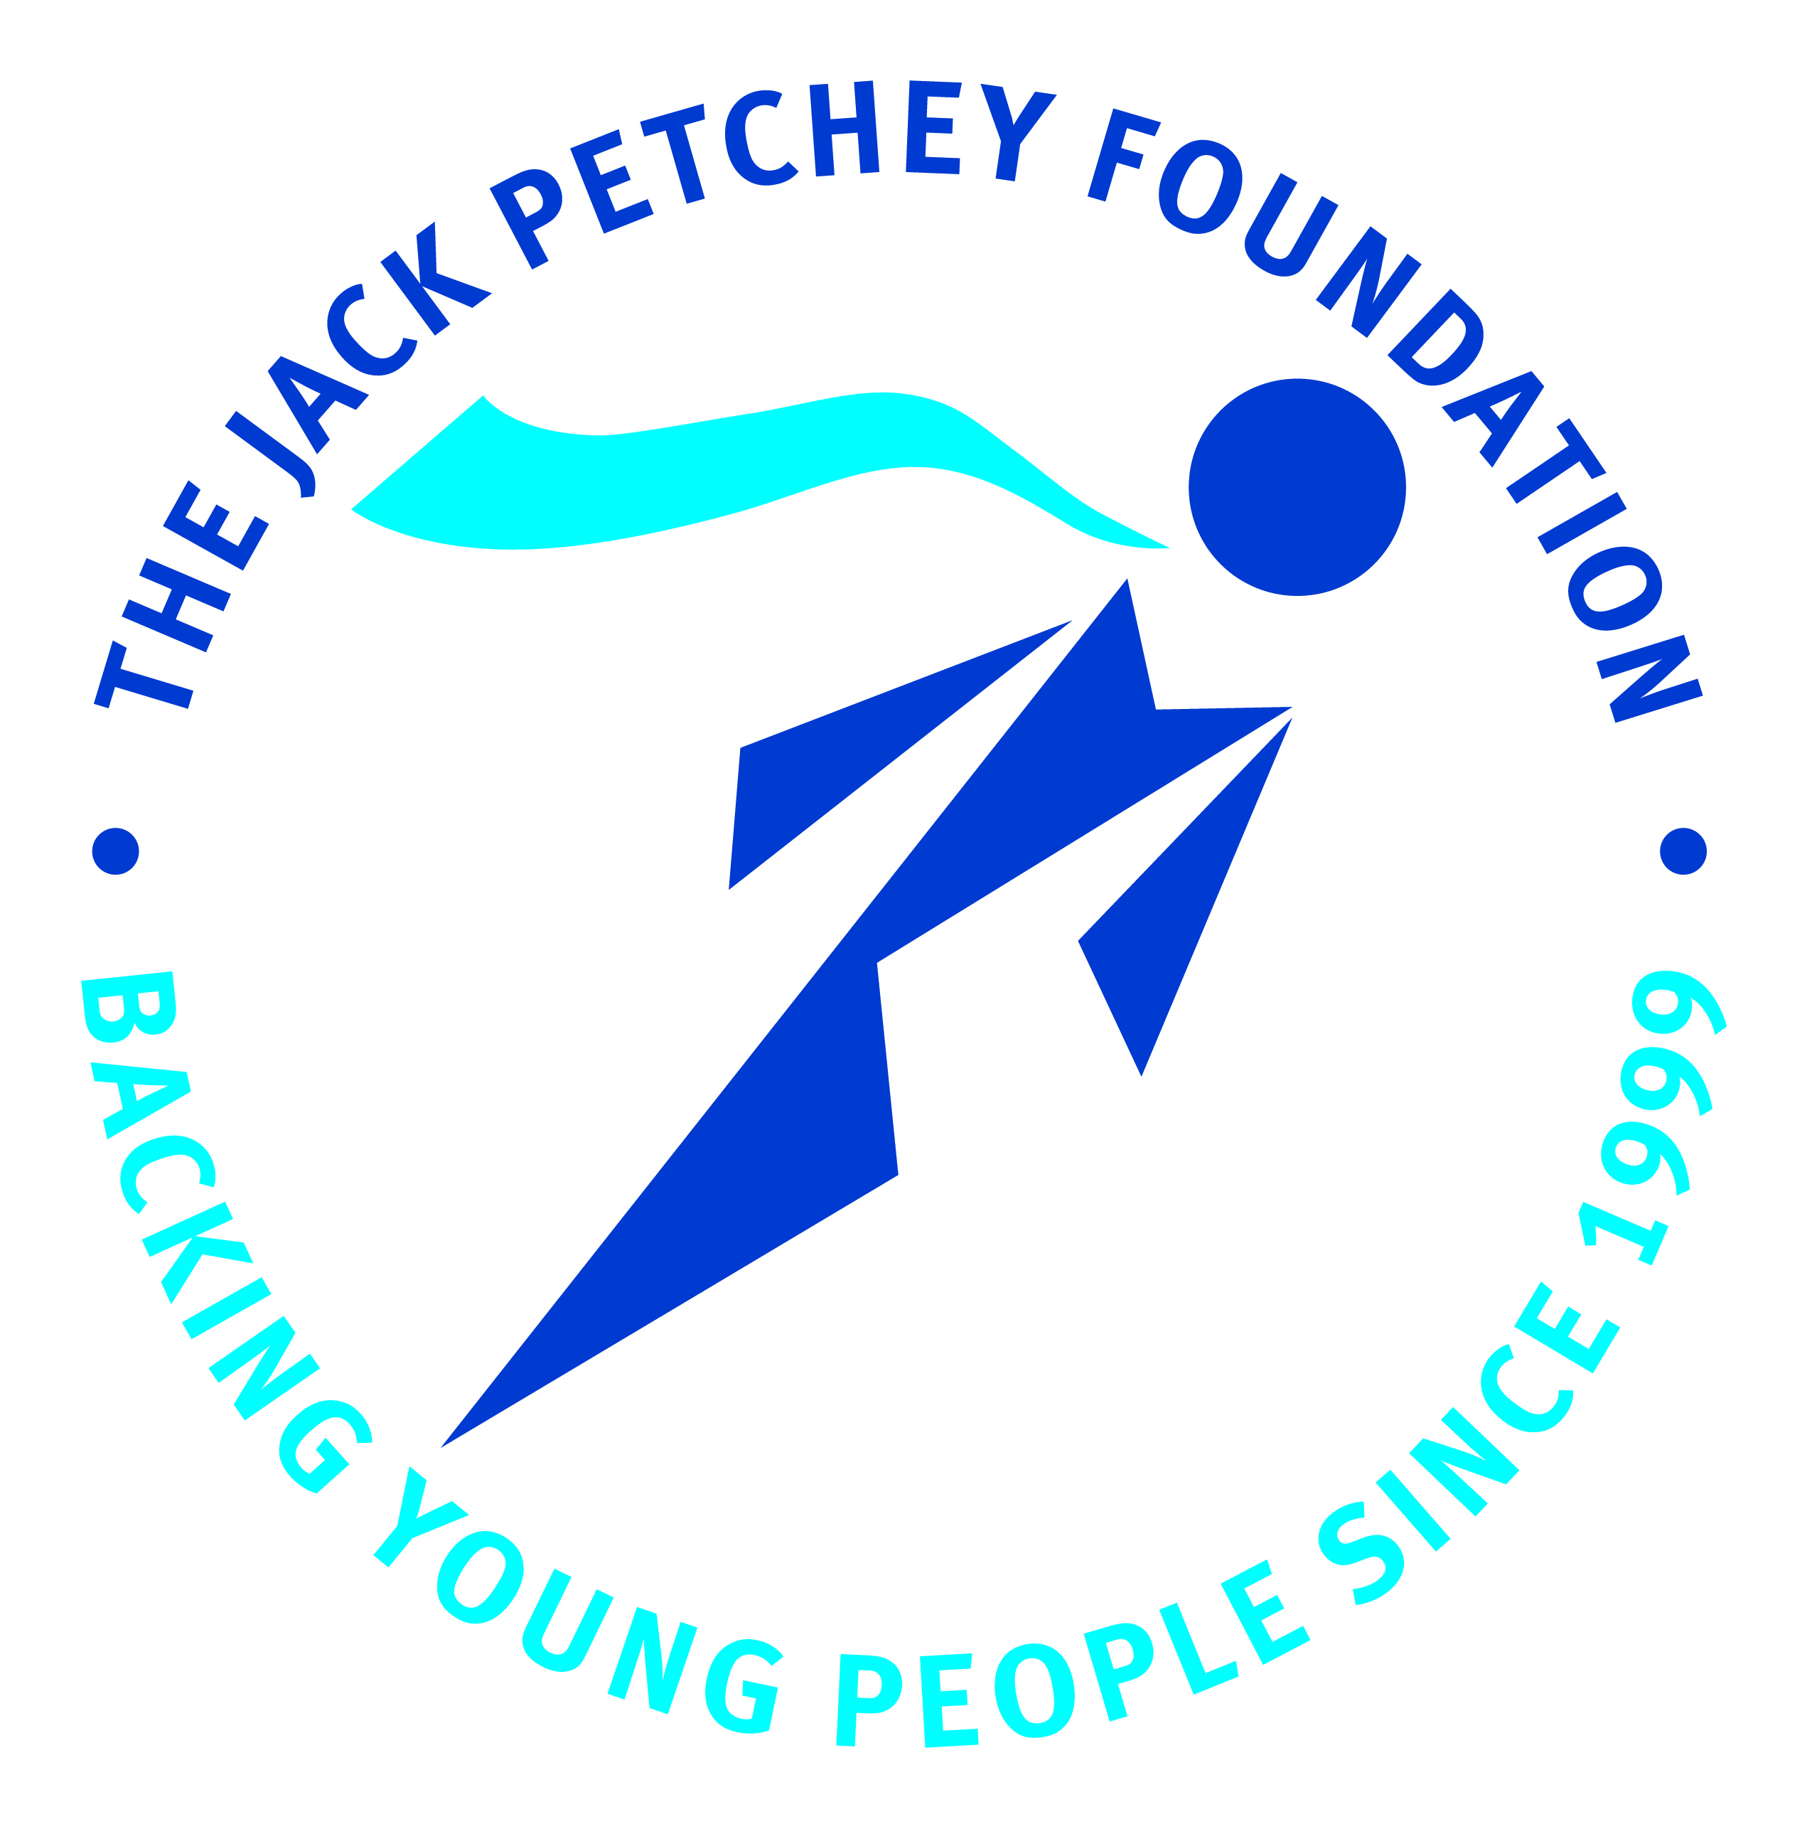

ACHIEVEMENT AWARD WINNER 2024/2025

Your school is entitled to elect a Jack Petchey Achievement Award Winner. Recipients do not have to be the best at sport, work or anything else, but they must have contributed to the school or local community in a significant way. Equally, Achievement Award Winners can be recognised for personal developments and positive personality traits. Achievement Award Winners must be aged between 11 and 25 years.

Achievement Award Winners will receive:

- A framed certificate
- A pin badge
- A boxed medallion
- £300 to be a spent on a school/community project of their choice

Please complete this form to make your nomination.

I nominate
I am a  (delete as appropriate) |  | Student/ Teacher/ Parent/ Staff Member/ Other
Reason for Nomination
Name |  |  | Signature |  | Date
If you wish to obtain the support of others
Name |  |  | Signature |  | Date

Please email completed form to gatkinson@harlow-college.ac.uk by Thursday 13th May 2025 Thank you.

