Introduction
This document gives an overview of how to update Actual Destination data for LR in Qube.

Updating Actual Destinations
Actual Destinations can be updated via Qube (http://redqube.harlow-college.ac.uk/index.php). By default Heads of Academies and AAMs have access to update Actual Destinations but access can be granted to others on request.
NB a student may be enrolled on several courses – however you only need to enter the destination data once for each student. The data will then appear against the student in his / her other courses.
- Log in to Qube as usual.
- At the bottom of the front page you will see the block below. Click on Add Actual Destinations.
- Select the Year, then Team, then Course / Class code from the dropdown lists.

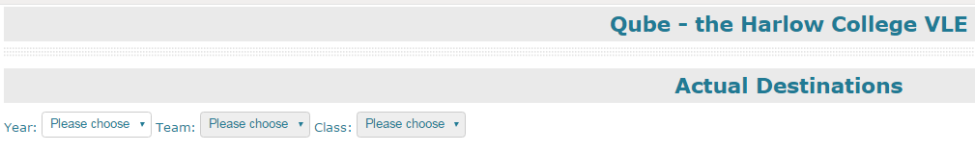
- Once you have chosen your Course you can select the Destination for each learner. You can also add extra information for certain choices. You must click the Update button for each learner you enter data for.
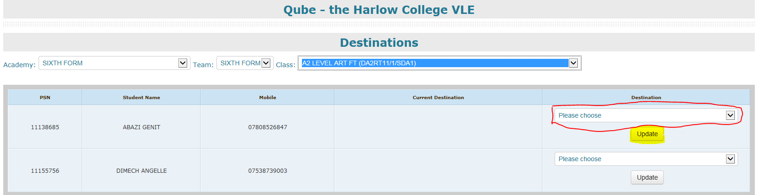

FAQ
Q. I can’t see the link to Add Actual Destinations, how do I get it?
A. If you do not have access, email Barbara Lawrence and she will provide the access rights. If you are not an AAM then they must request it on your behalf.

Q. How long does it take for updates to take effect?
A. Once you hit the update button in Qube, the update is effective immediately.

