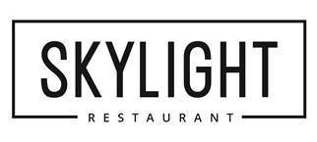

|  |
| --- |
| **Student Special Lunch** £4.50 for two courses  Wednesday, Thursday and Friday |
| **Student Evening of Celebration**  Thursday 17 May 5.30pm  £4.50 for a two course dinner [Click here for menu](http://redqube.harlow-college.ac.uk/mod/resource/view.php?id=114949) |

### Book now - call ****01279 868060**** or [email us at skylight@harlow-college.ac.uk](mailto:skylight@harlow-college.ac.uk?subject=Skylight%20booking)